**Report For Titanic Dataset**

**Problem Statement**

The dataset captures details of Uber rides taken, including start and end times, trip category (Business or Personal), start and stop locations, distance traveled (in miles), and the purpose of the trip. However, it lacks analysis to determine usage patterns, cost implications, purpose-specific trends, or efficiency in ride utilization. As ride-sharing becomes increasingly integral to corporate travel, understanding trip behaviors is vital to optimizing operations and managing expenses.

**Objective**

The primary objective of this analysis is to derive actionable insights from Uber ride data by:

* Identifying temporal patterns in ride usage (e.g., peak hours, days, or months).
* Analyzing the distribution of business vs. personal trips.
* Determining the most frequent start and stop locations.
* Evaluating trip purposes and their associated travel distances.
* Detecting anomalies or inefficiencies in travel (e.g., excessively long or short trips).
* Suggesting opportunities for improving travel policies or reducing costs.

**Visualization and Insights**

**Distribution of Uber Rides by Category and Trip Purpose**

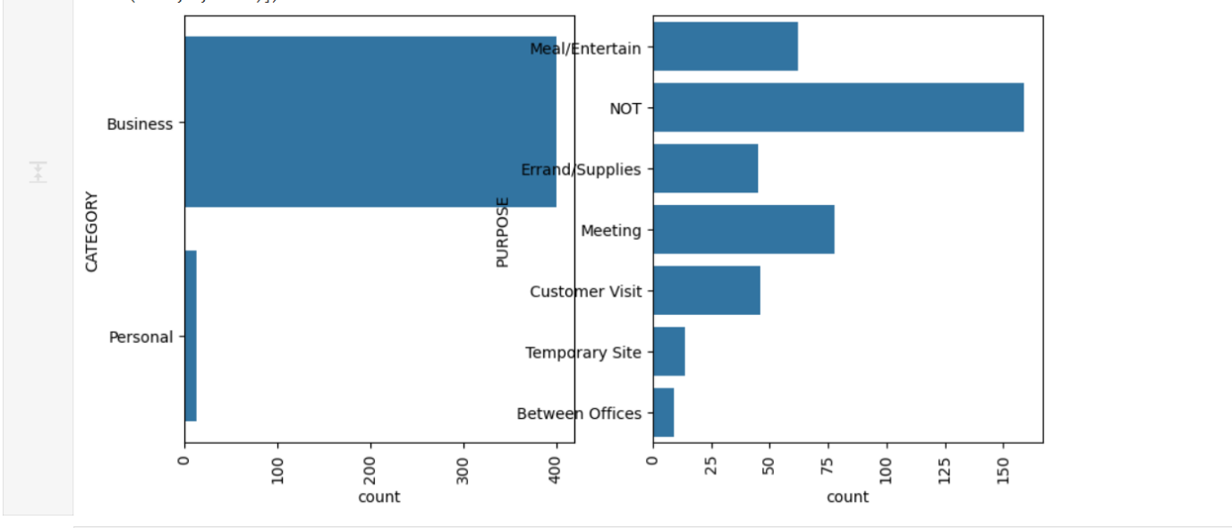

Observations:

Category Distribution:

* Business trips dominate the dataset (~1100+ trips).
* Personal trips are minimal (~100 trips), indicating corporate or work-related usage focus.

Purpose Distribution:

* Top Purpose: The most frequent label is “NOT”, implying many records lack a defined purpose. This points to missing data quality issues.
* Common Work Purposes:
  + Meeting, Customer Visit, and Meal/Entertain are among the most recorded purposes.
  + Errands/Supplies also appear significantly, indicating operational tasks.
* Less Frequent Purposes:
  + Rarely used purposes include Charity ($), Commute, Moving, and Airport/Travel, possibly suggesting niche or infrequent travel needs.

Insight:

This chart emphasizes that Uber usage is highly professional, and purpose data cleanup (especially “NOT”) would enhance analytical clarity.

**Uber Ride Activity Across Time of Day Segments**

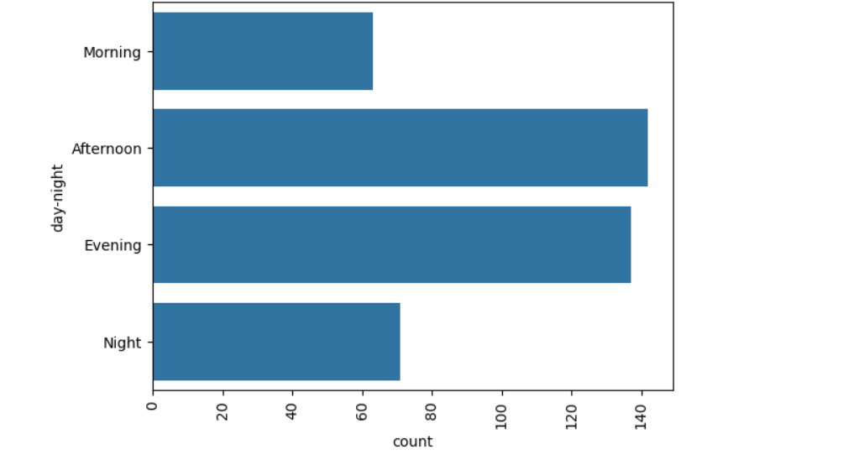

Observations:

* Most Frequent Times:
  + Afternoon and Evening are the most active travel times.
* Least Frequent:
  + Morning and Night trips are significantly lower, possibly reflecting regular office hours or avoidance of travel during less safe/dark hours.

Insight:

Rides are concentrated during daylight/working hours, indicating typical business hours influence. Policies could focus on ride pooling or rate optimization for peak timeframes.

**Comparison of Trip Purposes by Ride Category (Business vs. Personal)**

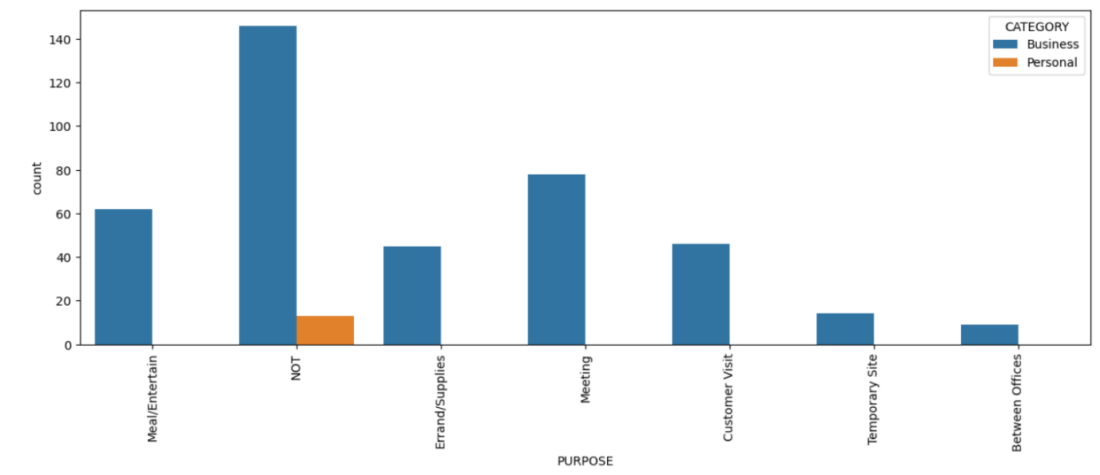

Observations:

* Business Dominates Across All Purposes:
  + Most purposes like Meeting, Customer Visit, and Meal/Entertain are overwhelmingly business trips.
* Personal Use is Minimal:
  + Slight presence in “NOT” purpose, but almost none in structured categories, reflecting very few personal rides being logged with a specific purpose.

Insight:

Uber usage is highly business-centric, and almost no personal rides are purpose-classified. The gap reveals an opportunity to:

* Educate employees on purpose entry,
* Better segment personal vs. business for expense tracking or audits.

**Heatmap**

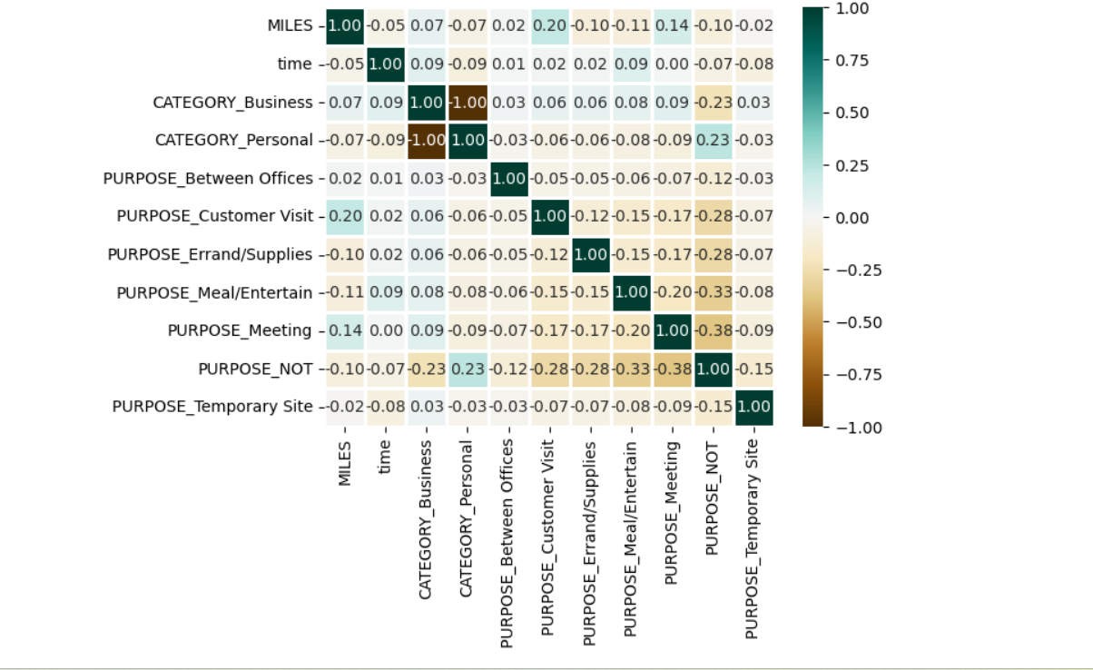

* Business and Personal Category are highly negatively correlated, this have already proven earlier. So this plot, justifies the above conclusions.
* There is not much correlation between the features**.**

**Monthly Trend Analysis of Uber Ride Activity**

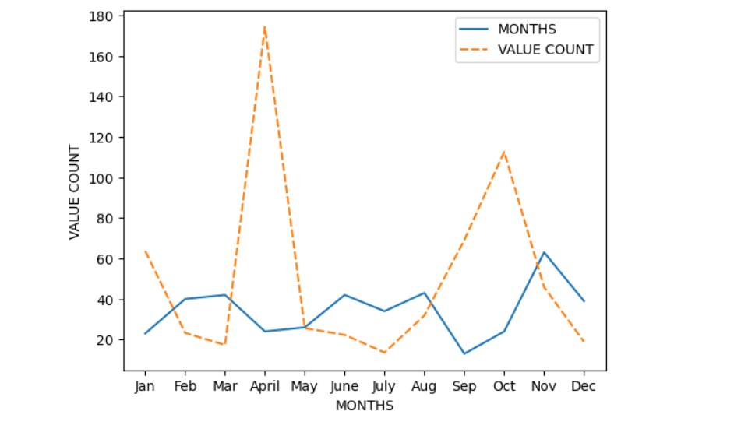

* The counts are very irregular.
* Still its very clear that the counts are very less during Nov, Dec, Jan, which justifies the fact that  time winters are there in Florida, US.